HackOR Website Design Reference

## Fonts:

Headers (including buttons/navigation): Synthese bold

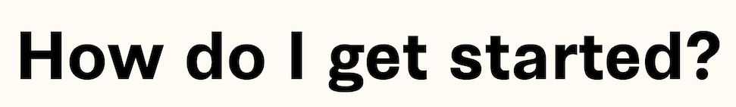

Body text: Noto Sans

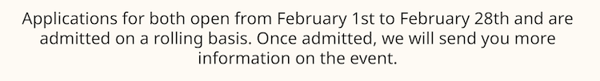

Sign text: Vinyl OT

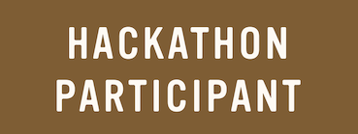

## Colors:

Background color (day): #FFFAF3 (EXAMPLE)

Background color (night): #273147 (EXAMPLE)

Accent color: #07B494 (EXAMPLE)